KWAME NKRUMAH UNIVERSITY OF SCIENCE AND TECHNOLOGY
COLLEGE OF ENGINEERING
DEPARTMENT OF AGRICULTURAL AND BIOSYSTEM ENGINEERING

CONSTRUCTION OF A POULTRY HOUSE FOR 10000 2-WEEKS OLD CHICKS

GROUP MEMBERS

KANKAM THERESA 4165315
ZILEVU HERO-GODSWAY 4167815
TSOGBE NEWEL MAWUNYO 4167715
FRIMPONG BRIGHT 4164515
SEGBEDZI STEPHEN ELORM 2307314
FRIMPONG JOEL OHENE 4164615

1. Introduction

1.1 Background study
Poultry farming is the process of raising domesticated birds such as chickens, ducks, turkeys and geese for the purpose of farming meat or eggs for food. Poultry are farmed in great numbers with chickens being the most numerous. Chickens raised for eggs are usually called layers while chickens raised for meat are often called broilers. Broilers are chickens that is bred and raised specifically for meat production and it will be, the major concern as this project is facilitated.
Poultry housing systems can be classified into three types thus extensive, semi-intensive and intensive. The system to used in this project is the intensive system since broiler are mostly reared in the deep litter system and this system also gives easy access to feed, water, egg collection, provide good protection. The cost effect is cheap as well.

1.2 Objective
The main objective for this project is to construct a house structure for 10,000 broilers (2 weeks old).
The specific objectives of the project are as follows;
- protect inclement weather thus direct sun rays and rain,
- provide safety from predator attacks,
- to apply scientific management practices,
- provide regular feed for the chicks on time.

2.1 Materials
The materials used for this is wood, the oak wood to be precise. The door handles are made of steel and the roof is made of aluminum.

3. Spacing and Ventilation systems

3.1 Spacing
The broiler house mostly pair chicks between 1000 – 1500 per pen and for design each chick in a pen has a space of 40cm² for movement and addition 30cm² added for each pen to allow throughs to be aligned for feed and water. The total square of each pen is 10000cm².

3.2 Ventilation System
There was an air vent window with wire frame covered at the back of the structure because the chicks are two weeks old and they need more heat. The air vent created behind is for the purpose of removing excess odour and gas from the pens.

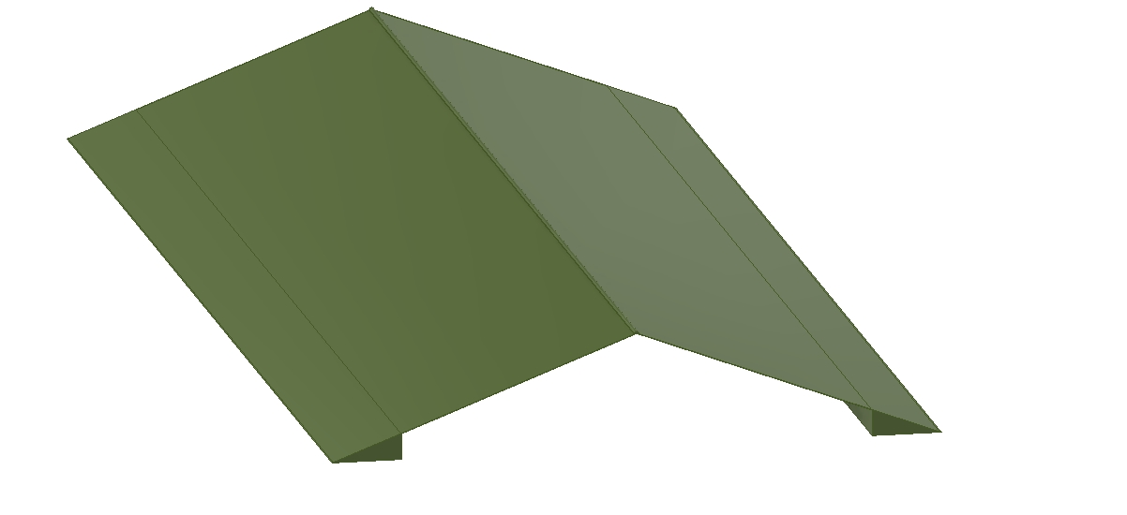
4. Equipment
Candescent bulbs installed in the structure to generate more heat for the chicks. Feed trough for the chicks to feed and a water trough for the chicks to drink water.

5. Justification
The structure was divided into 12 parts, 10 equal apartments for the chicks, 2 feed storage and a walk way to enhance ventilation. There would be 1000 broiler chicks per pen. Columns will be used at each edge (700cm distance) to support the structure and beams were put in place as well to help carry the load in the middle and at the top to carry the roof of the structure. A mesh will be used to cover the structure to enhance ventilation. A storeroom was also created for storing feed, essentials to help the growth of the broiler chicken and a washing area for the cleaning of the troughs of the chicks. A space has also been designed for storing feed and also equipments.

6. Conclusion
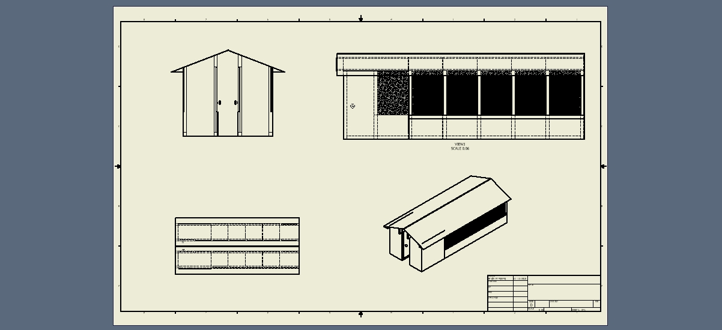
The structure has been constructed and the chicks will be free from predators, feeding and movement space is also provided. Heat for chicks is also provided for their warmth to help their growth.
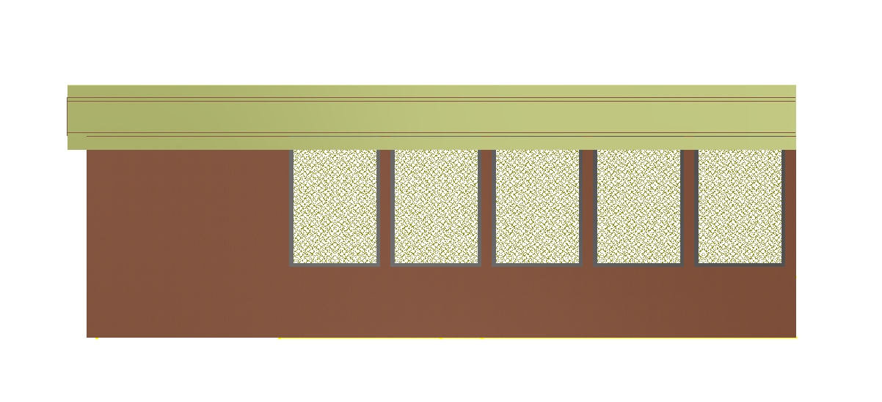

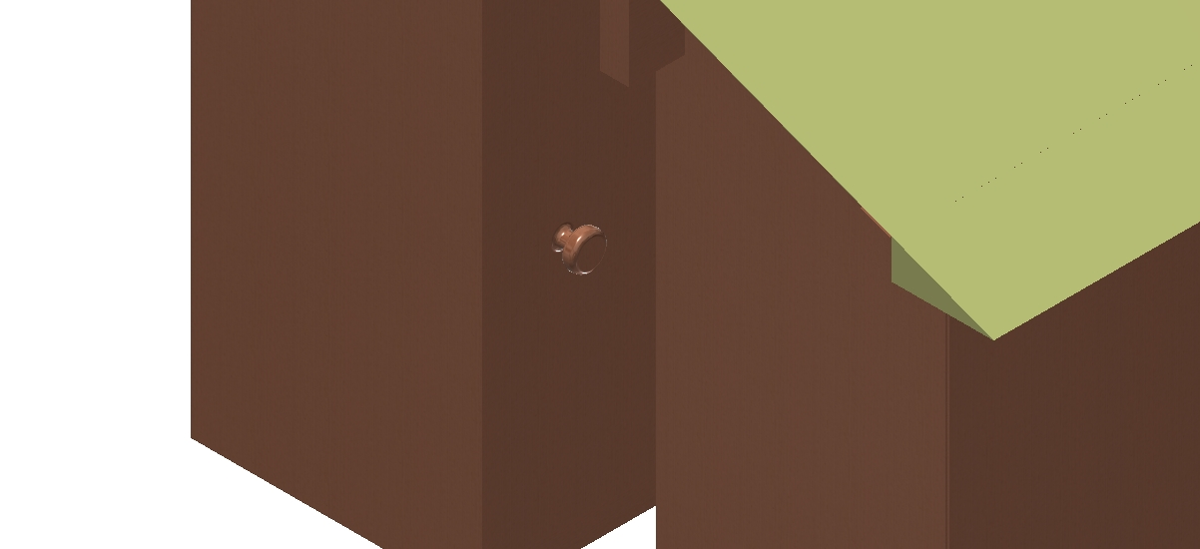
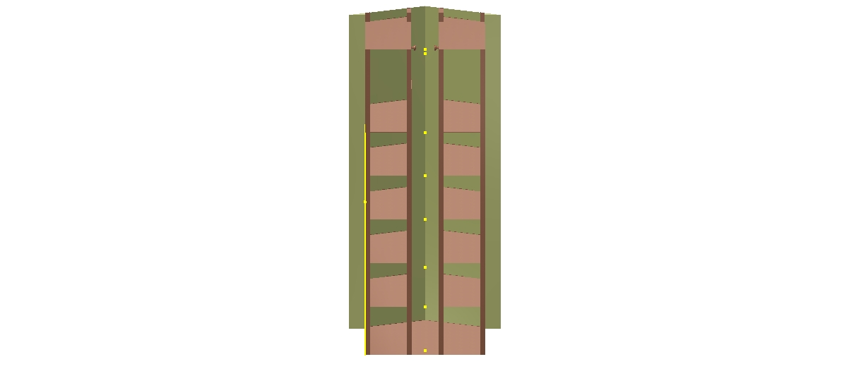


The pictorial views of the structure (the orthographic view, isometric view, the top view, and the roof).
Design for 10,000 broiler chickens.

